LAB 6: Time Response Analysis of Dynamic Systems

Course Number | MENG 3020
Course Title | System Modeling & Simulation
Semester/Year | Fall 2025

Lab/Tutorial Report No. | Lab 6
Report Title | Time Response Analysis of Dynamic Systems
Section No. | 0NA
Group No. | N/A
Submission Date | November 16th, 2025
Due Date | November 17th, 2025

Student Name | Signature* | Total Mark
Michaël McCorkell |  | / 50

* By signing above, you attest that you have contributed to this submission and confirm that all work you have contributed to this submission is your work. Any suspicion of copying or plagiarism in this work will result in an investigation of Academic Misconduct and may result in a ZERO on the work or possibly more severe penalties.
https://academic-regulations.humber.ca/2021-2022/17.0-ACADEMIC-MISCONDUCT

LAB 6 Grading Sheet

Student First Name:  Michaël | Student Last Name:  McCorkell
Part A: Analysis of First-Order Transfer Function Models |  | /10
PART B: Transfer Function Model of Nonlinear Systems from Step Response |  | /10
Part C: Analysis of Second-Order Transfer Function Models |  | /15
Post Lab Assignment |  | /10
General Formatting: Clarity, Writing style, Grammar, Spelling, Layout of the report |  | /5
Total Mark |  | /50

LAB 6: Time Response Analysis of Dynamic Systems

OBJECTIVES
- To understand some of the basic concepts behind the dynamic systems analysis, such as stability, time response characteristics, nonlinearity, and linear models.
- To explore step response of first-order and second-order systems and derive a first-order transfer function model of a nonlinear dynamic system from step response, and study the limitations of nonlinear systems modeling.

INTRODUCTION
POLES and ZEROES
Recall that the poles of a transfer function model are those values of the Laplace transform variable, $s$, for which the denominator of the transfer function is zero, including any roots shared with the numerator, i.e., roots of the denominator which `cancel' out with the numerator. Similarly, the zeros of a transfer function are those values of $s$ that cause the transfer function to become zero, including roots shared with the denominator.
STABILITY of LTI SYSTEMS
The time response of a linear time invariant (LTI) dynamic system $y\left(t\right)\text{=}y_{forced}\left(t\right)\text{+}y_{free}(t)$, where $y_{forced}(t)$ is the forced response (driven by the input applied to the system) and $y_{free}(t)$ is the free response (driven by the system's initial states).
A linear, time-invariant system is called:
- stable if the free response approaches zero as time approaches infinity.
- unstable if the free response grows without bound as time approaches infinity.
- marginally stable if the free response neither decays nor grows but remains constant or oscillates as time approaches infinity.
For LTI dynamic systems one can discuss stability easily in terms of the locations of the poles of the system's transfer function. A system is stable if all poles lie in the left-half of the complex s-plane (LHP). A system is unstable if its transfer function has at least one pole in the right-half of the complex plane (RHP), or a pole of multiplicity greater than one on the imaginary axis. A system is marginally stable if it has no poles in the RHP and only poles of multiplicity one on the imaginary axis.
FIRST-ORDER and SECOND-ORDER TRANSFER FUNCTION MODELS
First-order transfer function models has the following general form,
$$G\left(s\right)\text{=}\frac{K}{τs\text{+}1}$$
where, $K:$ is the steady-state gain,
$τ:$ is the time-constant,
The steady-state gain affects the final value of the step response, and the time-constant represents how fast the system response reaches the final value.
Second-order transfer function models has the following general form,
$$G\left(s\right)\text{=}\frac{Kω_{n}^{2}}{s^{2}\text{+}2ζω_{n}s\text{+}ω_{n}^{2}}$$
where, $K:$ is the steady-state gain,
$ζ:$ is the damping ratio,
$ω_{n}:$ is the natural undamped frequency,
The steady-state gain affects the final value of the step response, and the damping ratio and the natural undamped frequency determined the speed and stability of the response.
  - Under-damped Systems: $0\text{<}ζ\text{<}1$
  - Critically-damped Systems: $ζ\text{=}1$
  - Over-damped Systems: $ζ\text{>}1$
  - Undamped Systems: $ζ\text{=}0$

Part A: Analysis of First-Order Transfer Function Models
Consider the following transfer function models.
$$G_{1}\left(s\right)\text{=}\frac{0.5}{s\text{+}0.5}, G_{2}\left(s\right)\text{=}\frac{s\text{+}1}{0.5s\text{+}1}, G_{3}\left(s\right)\text{=}\frac{s\text{+}3}{s\text{+}0.3}, G_{4}\left(s\right)\text{=}\frac{1}{s\text{-}1}$$
Complete the required information in Table 1 for each transfer function:
Table 1
Transfer Function | Poles | Zeros | Initial Value of Step Response | Steady-State Value of Step Response | Stability  (YES/NO) | Time Constant
$$G_{1}(s)$$ | -0.5 | None | 0 | 1 | Yes | 2
$$G_{2}(s)$$ | -10 | -1 | 2 | 1 | Yes | 0.1
$$G_{3}(s)$$ | -0.3 | -3 | 1 | 10 | Yes | 3.33
$$G_{4}(s)$$ | 1 | None | 0 | Undefined | No | 1
- Start Simulink and open a new window.
- Create the following block diagram in Simulink: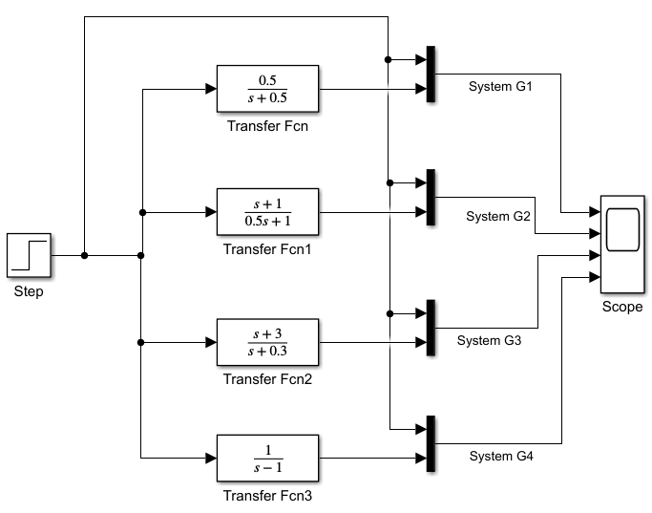
- Provide your Simulink model diagram below:
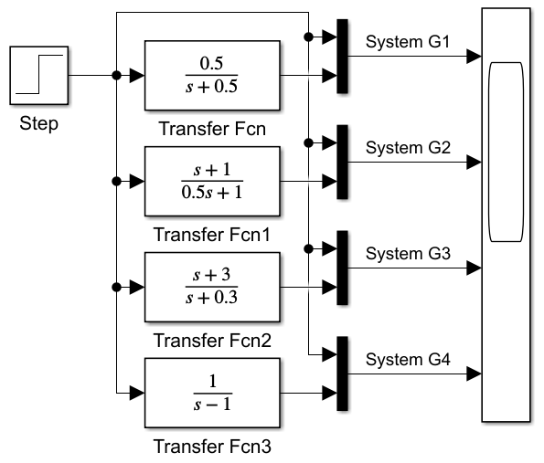

- Click on the Model Settings icon in the MODELING tab to open the Configuration Parameters window, click on the Solver details. Set the Relative tolerance value to 1e-12 to increase the resolution of the simulation. Then click OK.
- Save the model file as Lab6_PartA.slx.
- Set the Step Time of the Step block to 0. Set the simulation Stop Time 20$sec$ and Run the simulation. Open the Scope block. You will see the input-output curves for each transfer function. Provide the plot below:

- Compare the step response graphs with the results of Table 1. Are the results consistent with each other?
The step response results for the four systems are mostly consistent with the values listed in Table 1. G1(s) and G3(s) match the table perfectly in terms of initial value, steady-state value, and stable behavior. For G2(s), the plotted response shows an initial value of 2. Finally, G4(s) behaves exactly as expected for an unstable system—the response diverges rapidly—confirming that G4(s) is not stable despite the table’s description already marking it as unstable. Overall, the graphs agree with the expected system behavior after correcting the initial value of G2(s).

PART B: Transfer Function Model of Nonlinear Systems from Step Response

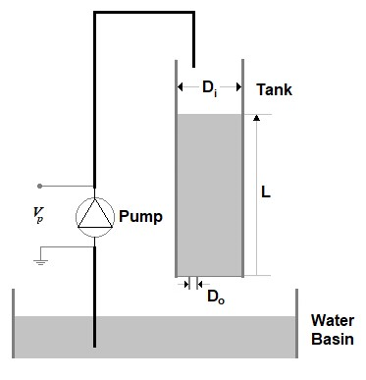
Dynamic models are essential for understanding the system behavior and design control systems. These models can either be derived mathematically from the first principles of physics of process or empirically from the step response of the process. The purpose of this part is to obtain a transfer function model of the following Single-Tank system experimentally from the input- output data.
Consider the following Single-Tank System as shown below:
The Single-Tank system consists of a pump with a water basin and a tank. The pump drives the water vertically from the bottom water basin up to the top of the system. The flow from the tank flows through an outlet orifice located at the bottom of the tank into the main water reservoir.
Liquid level control is common in many industries, such as pulp and paper mills, petrochemical plants and water treatment facilities.
Parameters of the Single-Tank system are defined as follows:
Figure 1: Single-Tank System
$V_{p}$: Voltage to the pump ($0V≤V_{p}≤50V$ )
$D_{i}:$ Tank inside diameter ($30 cm$)
$D_{o}:$ Out flow orifice diameter ($1 cm$)
$L:$ The water level in the tank
The rate of flow can be changed by changing the voltage of the pump ($V_{p}$) and/or by using outflow orifices with different diameters. Here, the voltage to the pump ($V_{p}$) is considered as the input to the process and the water level in the tank ($L$) is the output of the system.
Applying the mass balance principle to the water level in the Tank, the equation of motion of the Tank Is derived as:
$$A\frac{dL(t)}{dt}\text{=}F_{i}(t)\text{-}F_{o}(t)$$
where, $A$ is the area of the Tank,
$$A\text{=}\frac{πD_{i}^{2}}{4}$$
$F_{i}$ and $F_{o}$ are the inflow rates and outflow rates of the Tank, respectively. Assume that the volumetric inflow rate into the Tank is directly proportional to the applied pump voltage:
$$F_{i}(t)\text{=}K_{p}V_{p}(t)$$
where, $K_{p}$ is the pump flow constant. Applying the Bernoulli’s equation for small orifices, the outflow velocity from Tank can be expresses by the following relationship,
$$v_{o}(t)\text{=}\sqrt{2gL(t)}$$
where, $g$ is the gravitational acceleration. Lastly, the outflow rate from Tank can be expressed as below:
$$F_{o}(t)\text{=}A_{o}v_{o}(t)$$
where, $A_{o}$ is the outlet area of Tank.
$$A_{o}\text{=}\frac{πD_{o}^{2}}{4}$$
Therefore, the nonlinear differential equation of dynamic system is obtained as:
$$A\frac{dL(t)}{dt}\text{=}K_{p}V_{p}\left(t\right)\text{-}A_{o}\sqrt{2gL(t)}$$

- Open a new Simulink model window.
- Create the following nonlinear model of the Single-Tank system in Simulink.
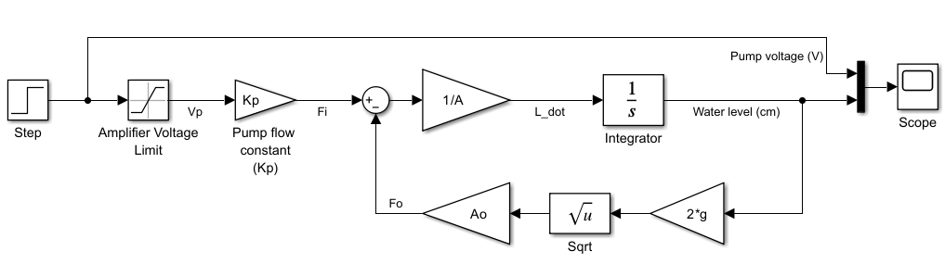
- Provide your Simulink model diagram below:
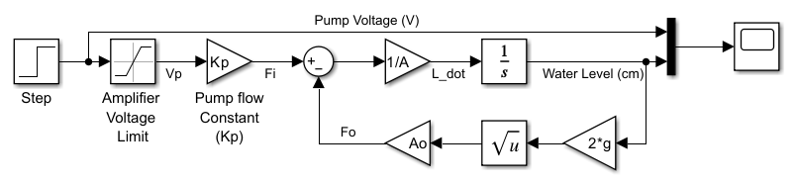

- Click on the Model Settings icon in the MODELING tab to open the Configuration Parameters window, click on the Solver details. Set the Relative tolerance value to 1e-12 to increase the resolution of the simulation. Then click OK.
- Save the model file as Lab6_PartB.slx.
- In the Saturation block, set the pump voltage limits as $0V≤V_{p}≤50V$.
- In the Step block, set Step Time to 0 and apply the Final value of 12V as the pump voltage.
- Right-click in the Simulink model window, select Model Properties from drop down menu. This will bring up the Model Properties dialog box.
- Select the Callbacks tab.
- Select InitFcn from the list of Model callbacks.
- Type the following MATLAB commands into the panel under Model initialization function. Click Ok. These commands will be executed at the start of the model simulation.
Di = 30; % Tank inside diameter [cm]
Do = 1; % Out flow orifice diameter [cm]
A = pi*Di^2/4; % Area of the Tank [cm^2]
Ao = pi*Do^2/4; % Outlet area of Tank [cm^2]
g = 981; % Gravitational acceleration [cm/s^2]
Kp = 10; % Pump flow constant [cm^3/V.s]
- Set the simulation Stop Time 1500$sec$ and, Run the simulation. Open the Scope block. You will see the pump voltage and the water level curves. Provide the plot below:
- Activate the Cursor Measurements of Scope and find the DC-gain and the time constant from the step response plot. Insert the required values in the first row of Table 2.
- Determine a first-order transfer function model for the system. Provide the transfer function model in the standard form as: $G\left(s\right)\text{=}\frac{K}{τs\text{+}1}$

Complete the first row of Table 2 based on your calculations.
Table 2
Applied Voltage (V) | Water Level (cm) | Time Constant (sec) | DC-gain (cm/V) | Transfer Function Model G(s)
12 V | 11.9 cm | 110 sec | 0.99167 | $$G\left(s\right)\text{=}\frac{0.99167}{110s\text{+}1}$$
15 V | 18.59 cm | 137.5 sec | 1.2393 | $$G\left(s\right)\text{=}\frac{1.2393}{137.5s\text{+}1}$$
18 V | 26.75 cm | 164.7 sec | 1.4861 | $$G\left(s\right)\text{=}\frac{1.4861}{164.7s\text{+}1}$$

- Create the first-order transfer function model in Step 21 and add it to your Simulink model as shown below:
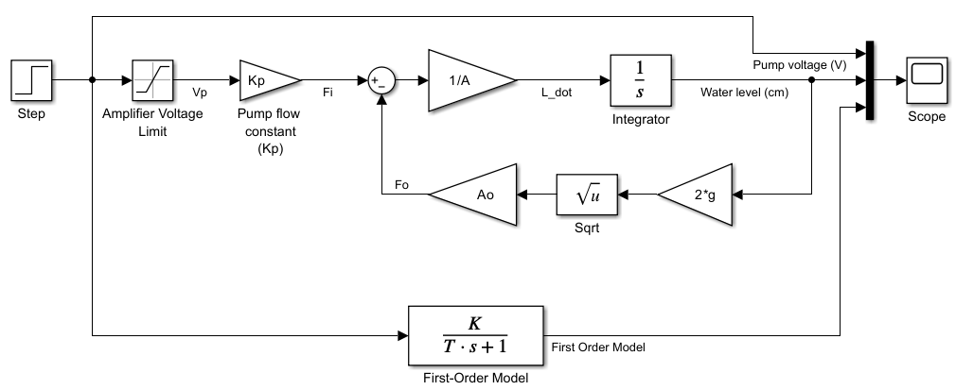
- Run the simulation. Open the Scope block. Compare the step response of the nonlinear system and the linear first-order transfer function model. Is the linear model acceptable?
The linear first-order model appears to be a reasonable approximation, particularly for steady-state analysis and
cases where an approximate transient reaction is adequate. However, because of its inability to accurately
represent nonlinear dynamics, the linear model may introduce modest flaws for very precise transient response
analysis. Overall, the linear model may be deemed sufficiently accurate for a variety of practical applications.

Provide the plot below:
Pump Voltage = 12V & Water Level (cm)

- Change the applied voltage according to the provided values in Table 2. Plot the graphs and provide them below.
Pump Voltage = 15V & Water Level (cm) Pump Voltage = 18V & Water Level (cm)
- Find the DC-gain, the time constant and the transfer function model for each system and complete the Table 2.
- Compare the obtained linear transfer function models in Table 2 for each operation point. Explain effect of changing the operating point of the nonlinear Single-Tank system on the linear model. Can we use a single model for all operation points?
The change in both time constant and DC gain shows that the system's dynamics vary with the operating point. As the water level increases, the system:
- Responds more slowly (higher time constant), likely due to the increased resistance to further increases in water level as the tank fills.
- Becomes more sensitive to input changes (higher DC gain), meaning that a small change in voltage has a larger impact on the water level at higher points.
This variability in the model parameters is characteristic of nonlinear systems, where the system behavior depends on the operating point.
In conclusion, a single linear model is insufficient for accurately representing the system’s behavior across all operating points. Instead, multiple linear models or a nonlinear model would better capture the system’s dynamics across different voltage levels and water heights.

Part C: Analysis of Second-Order Transfer Function Models
Consider the series RLC circuit as shown in Figure 2,
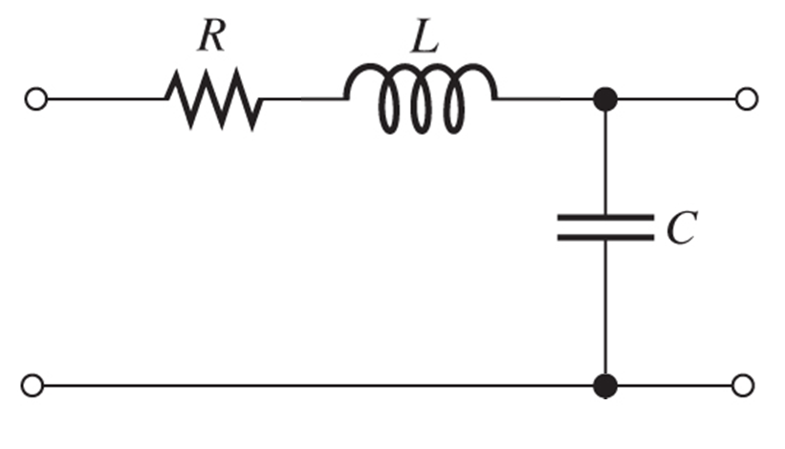
$$v_{a}(t)$$
$$v_{c}(t)$$

Figure 2: Series RLC Circuit

The dynamic model of this system is described by the following ordinary differential equation,
$$v_{a}\left(t\right)\text{=}LC\frac{d^{2}v_{c}(t)}{dt^{2}}\text{+}RC\frac{dv_{c}(t)}{dt}\text{+}v_{C}\left(t\right)$$
where $R:$ Resistance ($Ω$),
$C:$ Capacitance (F),
$L:$ Inductance (H),
$v_{a}\left(t\right):$ Applied voltage (V),
$v_{c}\left(t\right):$ Voltage across the capacitor (V),

Considering the $v_{a}\left(t\right)$ as the input and $v_{c}(t)$ as the output, the transfer function model is obtained as below,
$$G\left(s\right)\text{=}\frac{V_{c}\left(s\right)}{V_{a}\left(s\right)}\text{=}\frac{1}{LCs^{2}\text{+}RCs\text{+}1}$$
- Find the transfer function model in the standard second-order transfer function form and determine the DC-gain $K$, damping ratio $ζ$ and the undamped natural frequency $ω_{n}$ in terms of the $R$, $C$ and $L$ values and complete Table 3. Show your work below.
$$Standard Form → \frac{Kω_{n}^{2}}{s^{2}\text{+}2ζω_{n}s\text{+}ω_{n}^{2}}$$
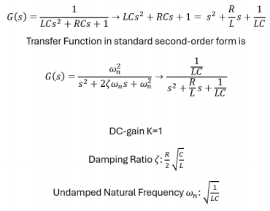

Table 3
Transfer Function Model | DC – gain $K$ | Damping Ratio $ζ$ | Undamped Natural Frequency $ω_{n}$
$$G\left(s\right)\text{=}\frac{1}{{LCs}^{2}\text{+}RCs\text{+}1}$$ | 1 | $$\frac{R}{2}\sqrt{\frac{C}{L}}$$ | $$\sqrt{\frac{1}{LC}}$$

- Assume that $R\text{=}100 Ω, C\text{=}0.05 F, L\text{=}5H$. Open a new script file and run the following code in MATLAB to create the transfer function model of the system.

R = 100; % Resistance (Ohms)
C = 0.05; % Capacitance (F)
L = 5; % Inductance (H)

num = [1/(L*C)]; % Numerator coefficients
den = [1 R/L 1/(L*C)]; % Denominator coefficients
G = tf(num,den) % Create transfer function

z = R*sqrt(C/L)/2 % Damping Ratio
wn = 1/sqrt(L*C) % Undamped Natural Frequency (rad/sec)

P = pole(G) % Poles

figure; pzmap(G) % Pole-Zero Map
figure; step(G) % Step response plot
xlim([0 30]) % Time axis limit of step response plot

stepinfo(G) % Step response specifications

Provide the results from MATLAB Command window and complete the first row of Table 4:
$G\text{=}\frac{4}{s^{2}\text{+}20s\text{+}4}$ $P\left\{\begin{aligned}−19.7980 \\ −0.2020\end{aligned}\right\}$
z = 5
wn = 2

Rise Time: 10.8747
Transient Time: 19.4140
Settling Time: 19.4140
Settling Min: 0.9035
Settling Max: 0.9993
Overshoot: 0
Undershoot: 0
Peak: 0.9993
Peak Time: 36.2413

Pole-Zero Map (R = 100Ω) Step Response Plot (R = 100Ω)
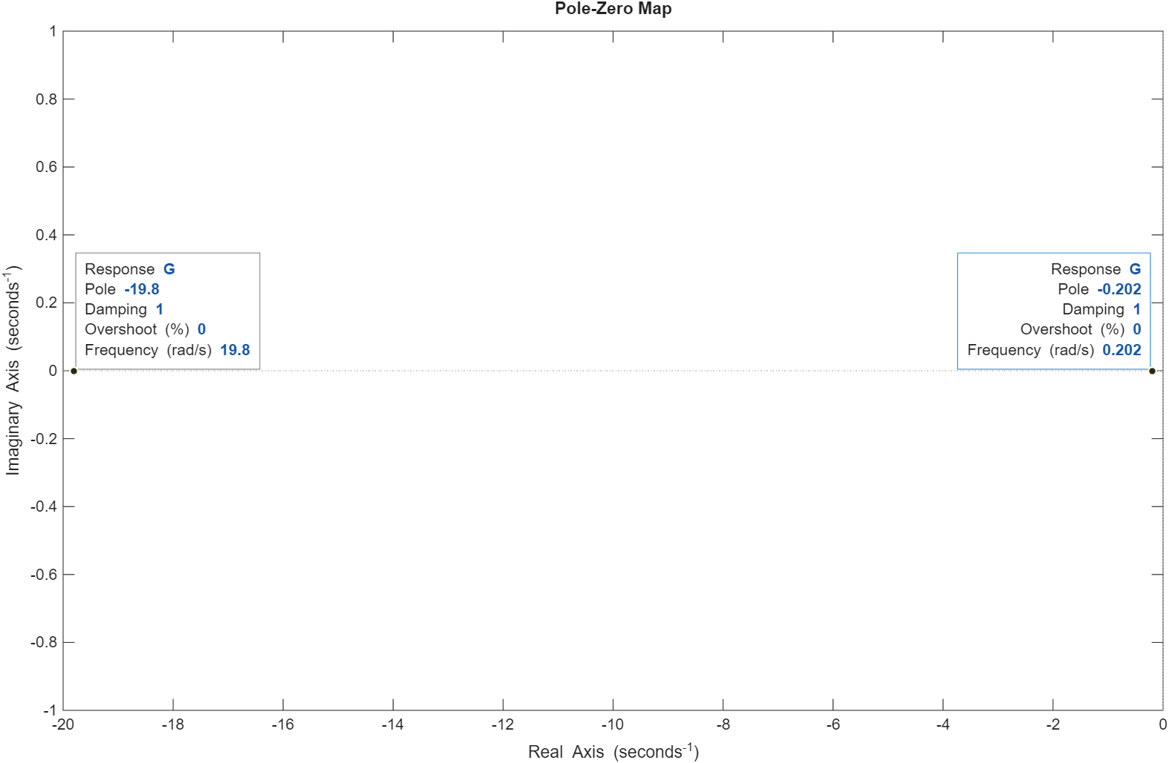

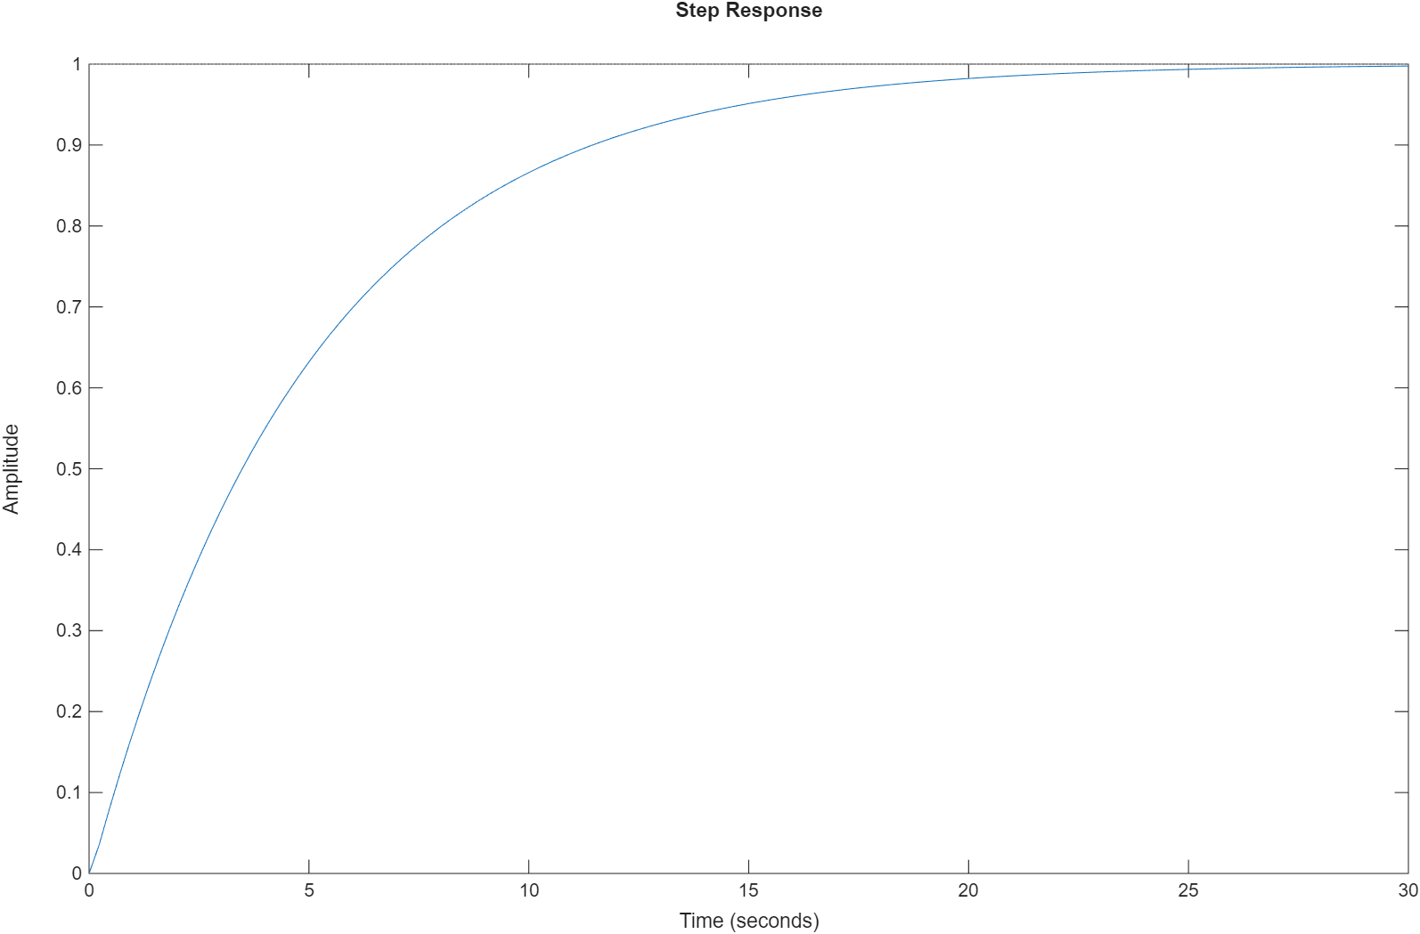

Table 4
Resistance (Ohms) | Poles | Damping Ratio $ζ$ | Undamped Natural Frequency $ω_{n}$ | System damping type | Rise Time | Percent of Overshoot | Settling Time
100 Ω | -19.8  -0.202 | 5 | 2 | Overdamping | 10.8747 | 0 | 19.4140
50 Ω | -9.5826  -0.4174 | 2.5 | 2 | Overdamping | 5.2678 | 0 | 9.4787
20 Ω | -2  -2 | 1 | 2 | Overdamping | 1.6790 | 0 | 2.9170
10 Ω | -1+1.7321i  -1-1.7321i | 0.5 | 2 | Underdamped | 0.8195 | 16.2929 | 4.0379
5 Ω | -0.5+1.9365i  -0.5-1.9365i | 0.25 | 2 | Underdamped | 0.6343 | 44.3235 | 7.0579
0 Ω | 0+2i  0-2i | 0 | 2 | Undamped | NaN | NaN | NaN
- Change the Resistance according to the given values in Table 4. Provide the required graphs, calculations, and data from the simulation and complete Table 4.
- Explain the effect of changing the Resistance on the damping ratio and the natural frequency of the system.
Increasing resistance results in higher damping ratios, making the system more overdamped and reducing oscillations.
Decreasing resistance lowers the damping ratio, moving the system toward underdamped behavior with more oscillations and higher overshoot.
Natural frequency remains unchanged at ωn =2 for all resistance values, indicating that it is independent of the
resistance in this setup.

Pole-Zero Map (R = 20Ω) Step Response Plot (R = 20Ω)
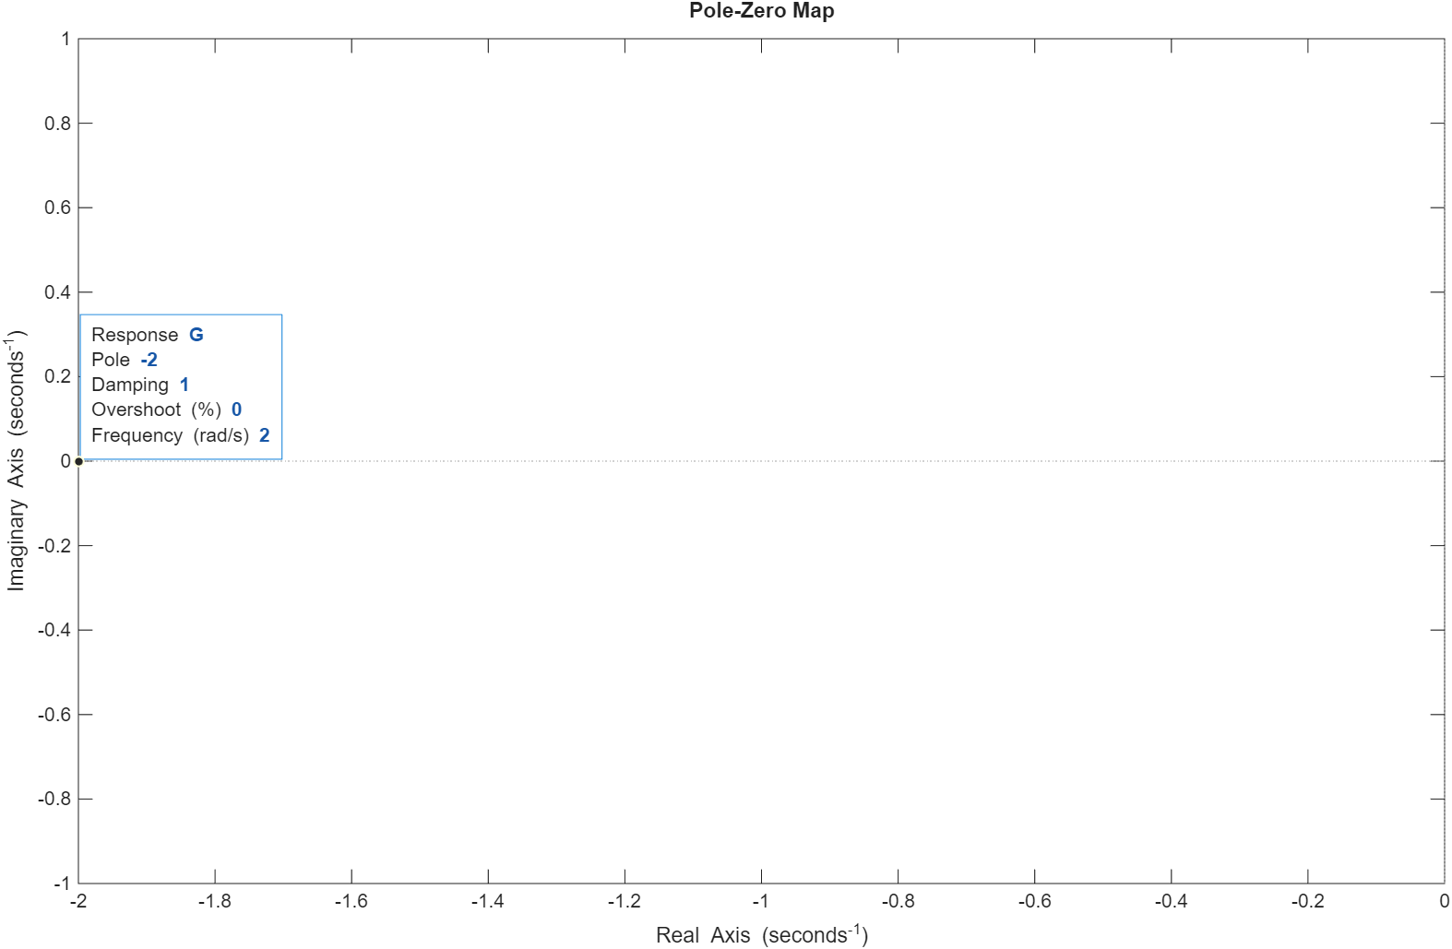

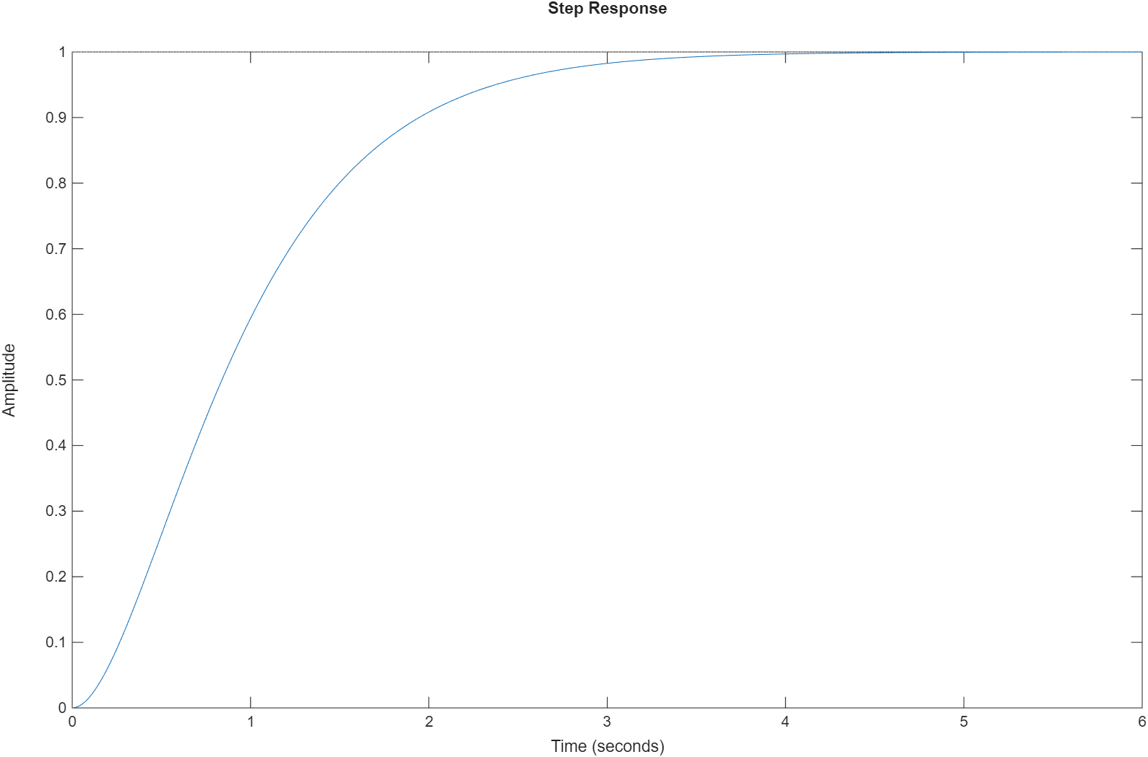

Pole-Zero Map (R = 5Ω) Step Response Plot (R = 5Ω)
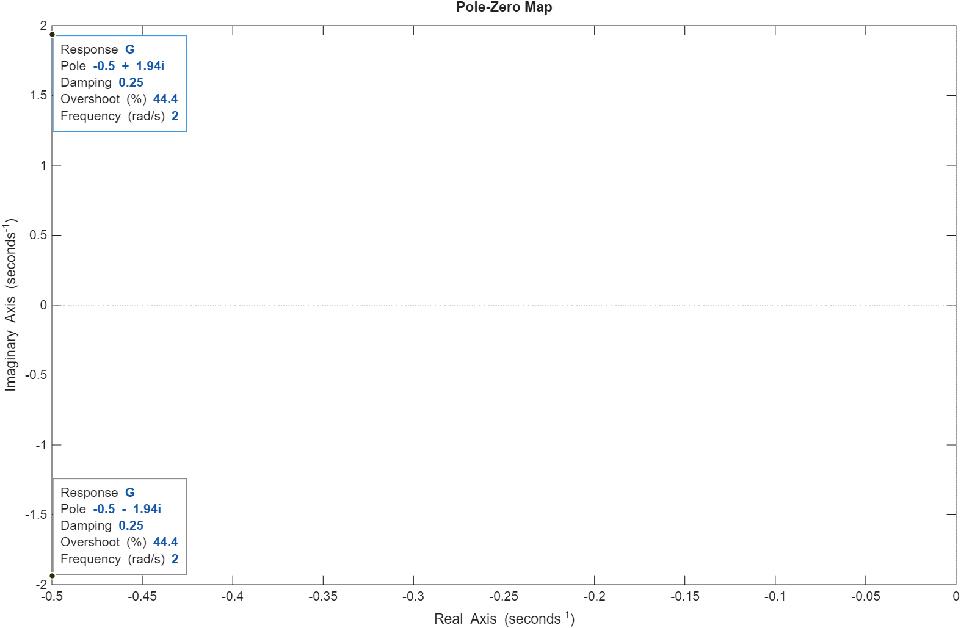

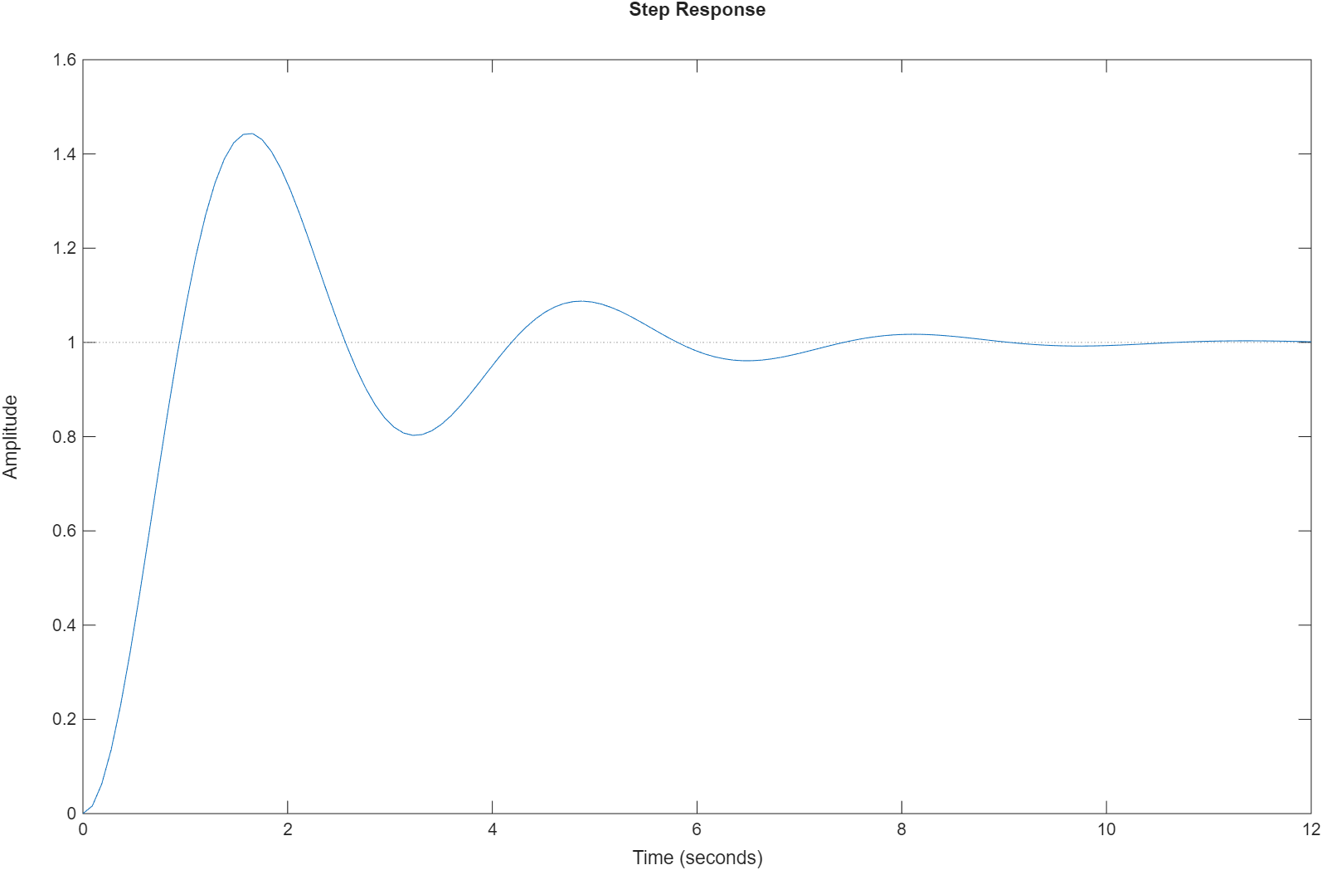

Pole-Zero Map (R = 0Ω) Step Response Plot (R = 0Ω)
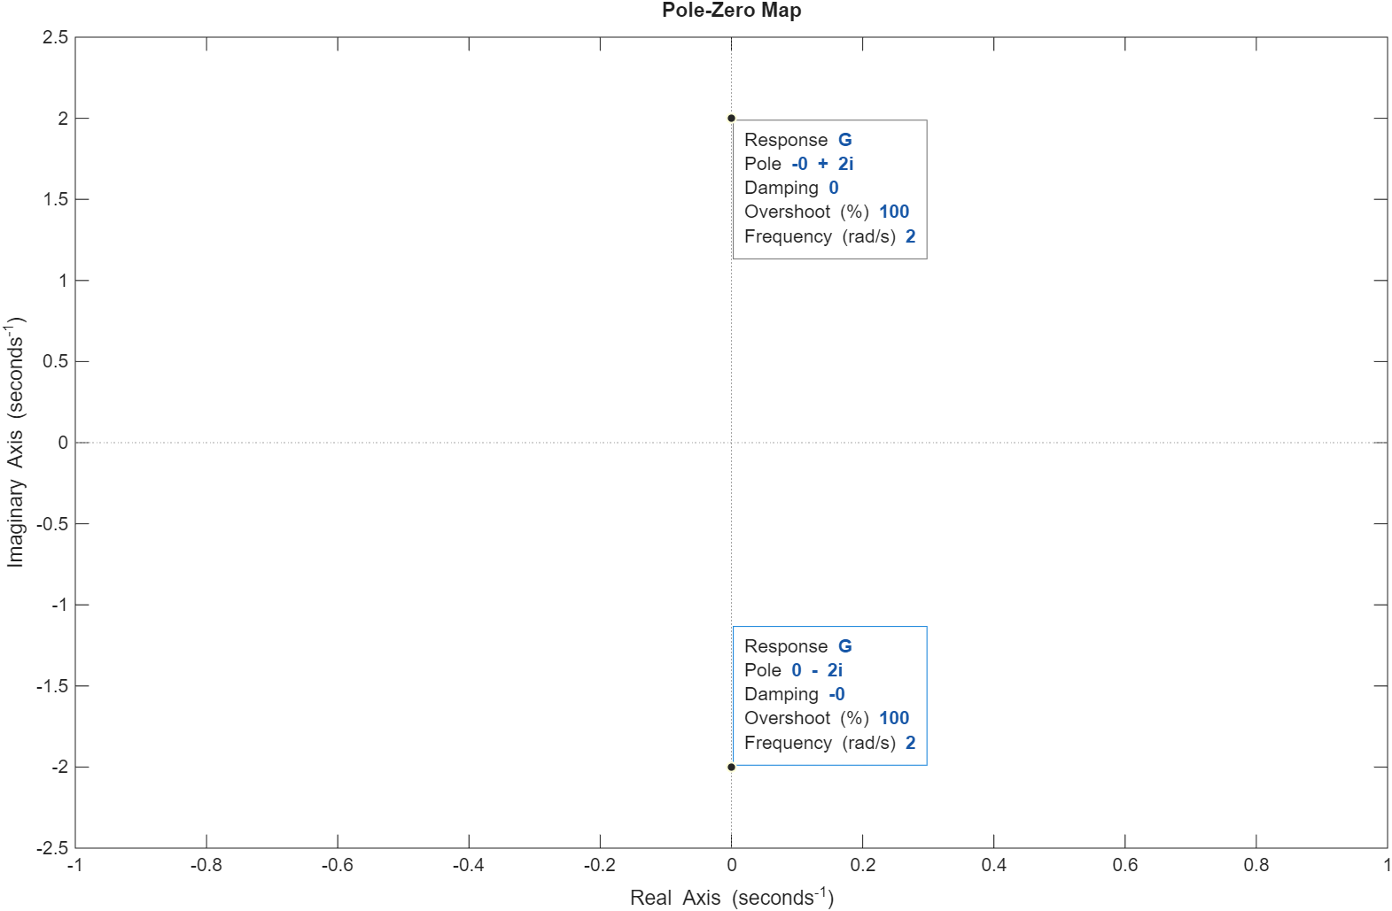

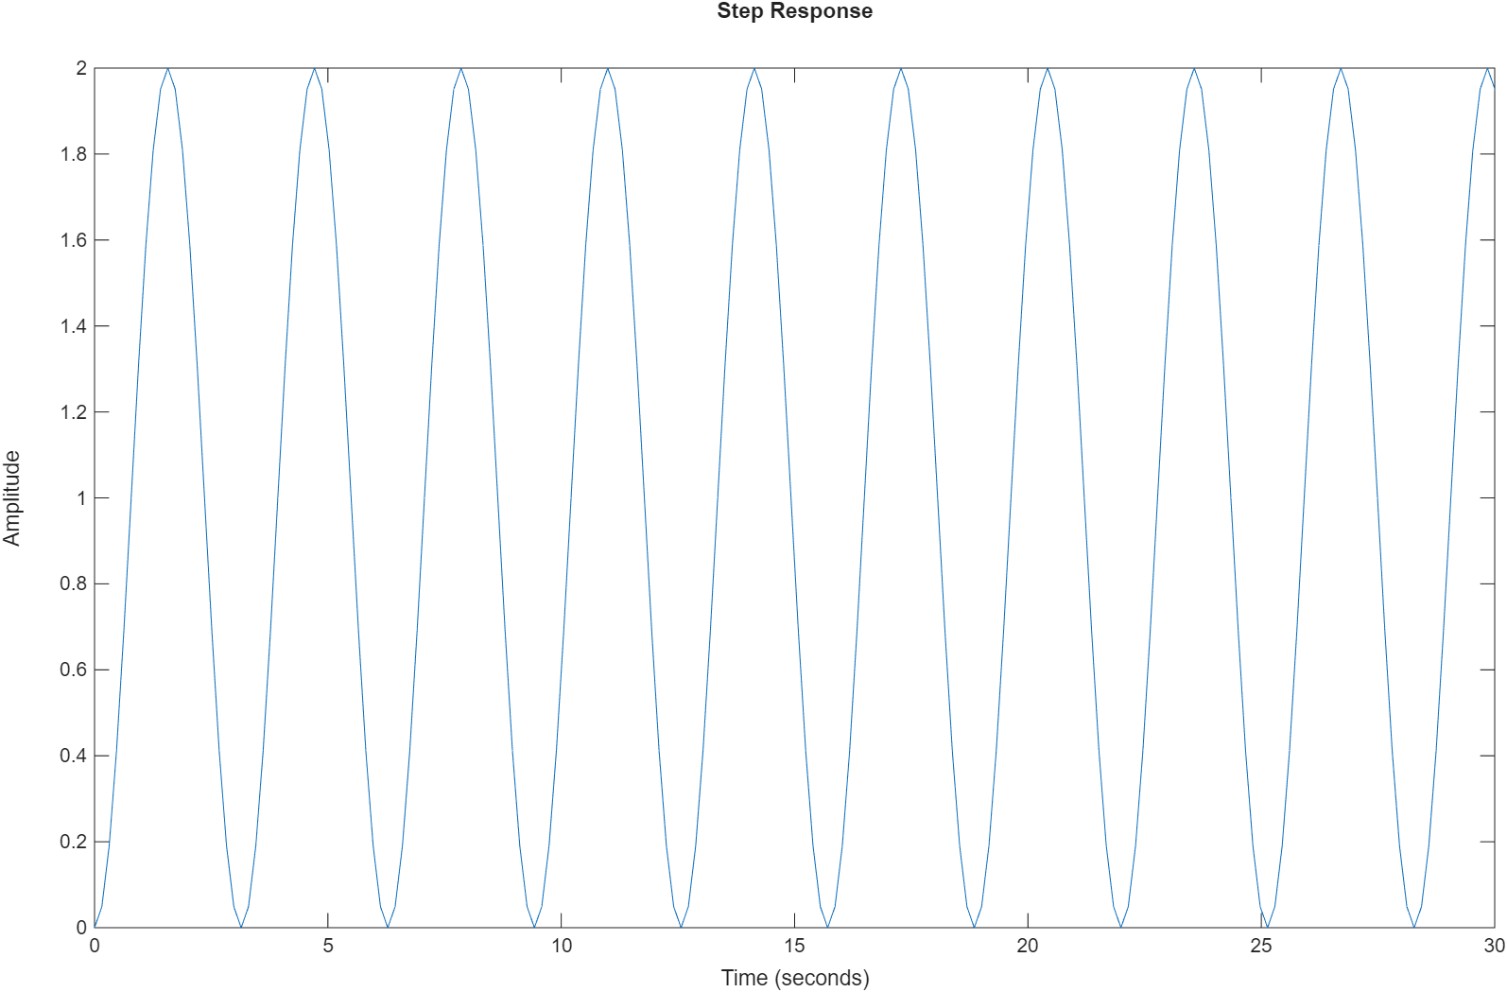

Post Lab Assignment
- Consider the following transfer function models:
$$G_{1}\left(s\right)\text{=}\frac{2.5}{s^{2}\text{+}3s\text{+}2}, G_{2}\left(s\right)\text{=}\frac{2.5}{s^{2}\text{+}2s\text{+}1}, G_{3}\left(s\right)\text{=}\frac{5}{s^{2}\text{+}4s\text{+}13}, G_{4}\left(s\right)\text{=}\frac{10}{s^{2}\text{+}10}$$
- Create a MATLAB code to obtain the transfer function and pole locations. Provide your code and the results.
- Plot the step response and the pole-zero map of each model. Provide the graphs.
- Determine the damping ratio and the undamped natural frequency of the models. Show your calculations.
- Determine the damping type of each system. Over-damped, under-damped, critically-damped or undamped? Justify your answer.

- For a system output given in the following figure and the following information, determine a second-order transfer function model. Show your calculations.
$$G\left(s\right)\text{=}\frac{Kω_{n}^{2}}{s^{2}\text{+}2ζω_{n}s\text{+}ω_{n}^{2}}$$
Peak time = 0.355 sec
Overshoot = 28.7%
Steady state value = 1.06
Rise time = 0.15 sec
Settling time = 1.13 sec
Peak Time
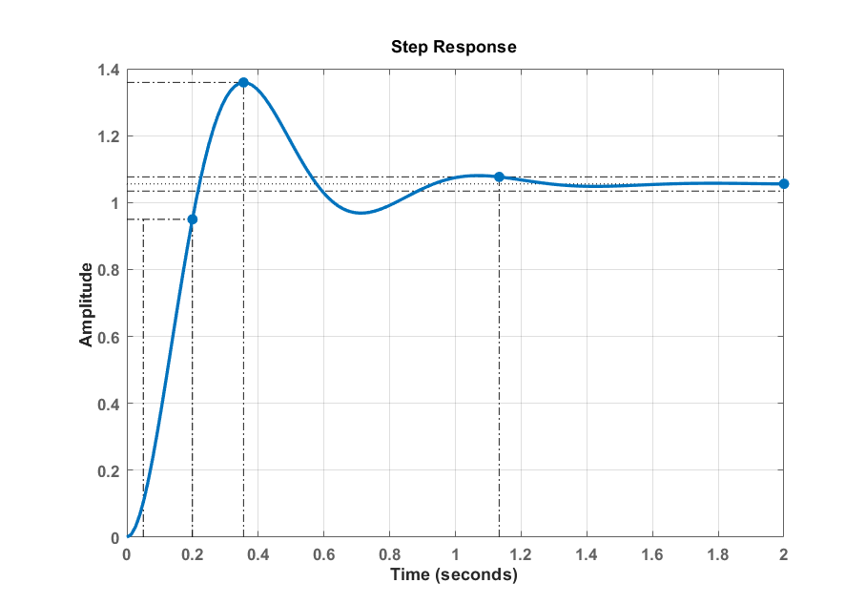
Settling Time
Rise Time
Steady State
Plot the step response of the model and show the peak time, overshoot, rise-time, settling-time and steady-state value on the graph. Provide your code and the graph.
Post Lab Assignment 1)

num1 = 2.5; % Numerator coefficients
den1 = [1 3 2]; % Denominator coefficients
G1 = tf(num1,den1) % Create transfer function

G1 =
2.5
-------------
s^2 + 3 s + 2
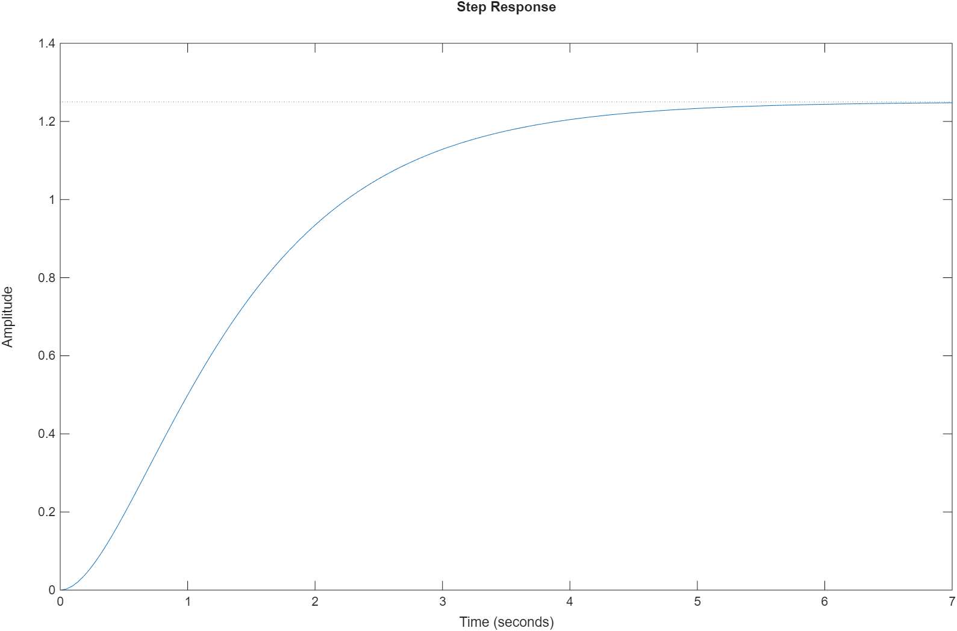

$$\begin{aligned}w_{n}\text{=}\sqrt{2}≈1.414 \\ 2ξw_{n}→3 \\ ξ\text{=}\frac{3}{2w_{n}}\text{=}\frac{3}{2∗1.414}\text{=}1.061\end{aligned}$$

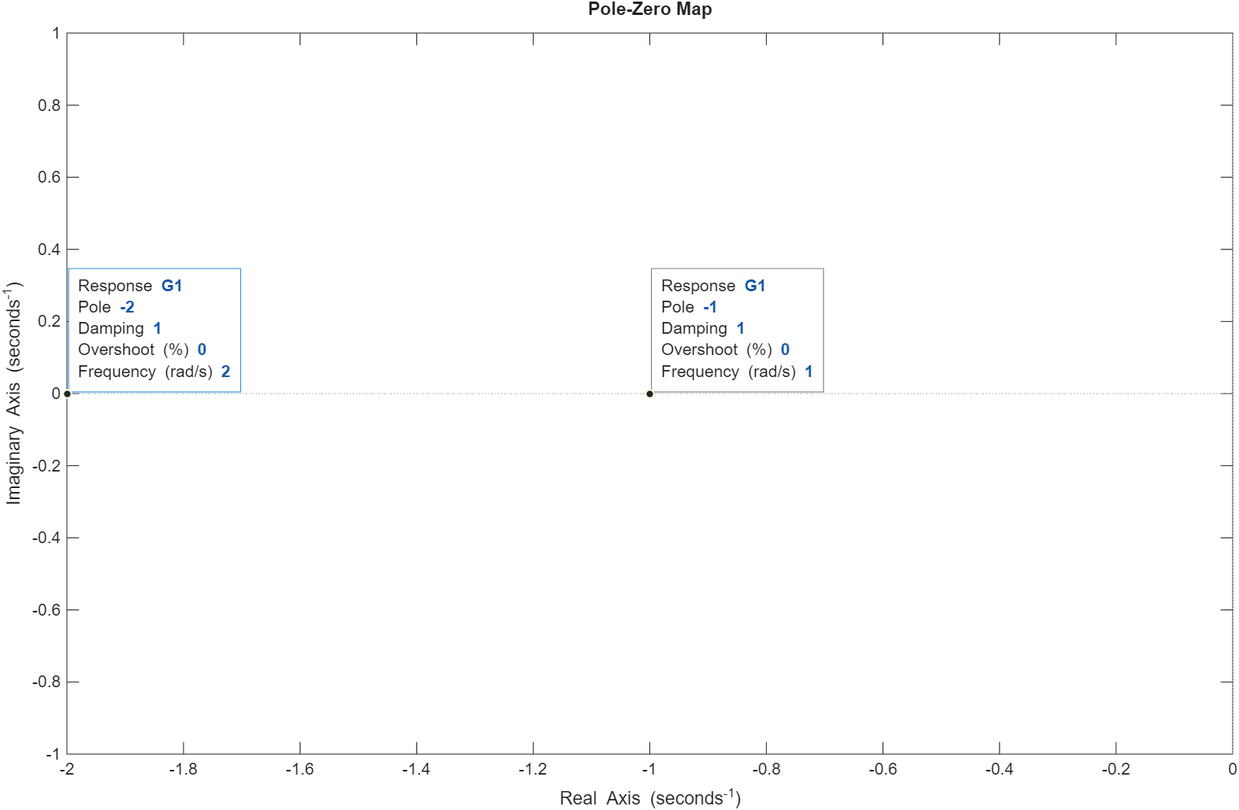
The damping ratio is slightly greater than 1, meaning the system is over-damped, and it will return to steady-state without oscillating but more slowly than a critically damped system

1.061 -> Overdamped

num2 = 2.5; % Numerator coefficients
den2 = [1 2 1]; % Denominator coefficients
G2 = tf(num2,den2) % Create transfer function

G2 =
2.5
-------------
s^2 + 2 s + 1
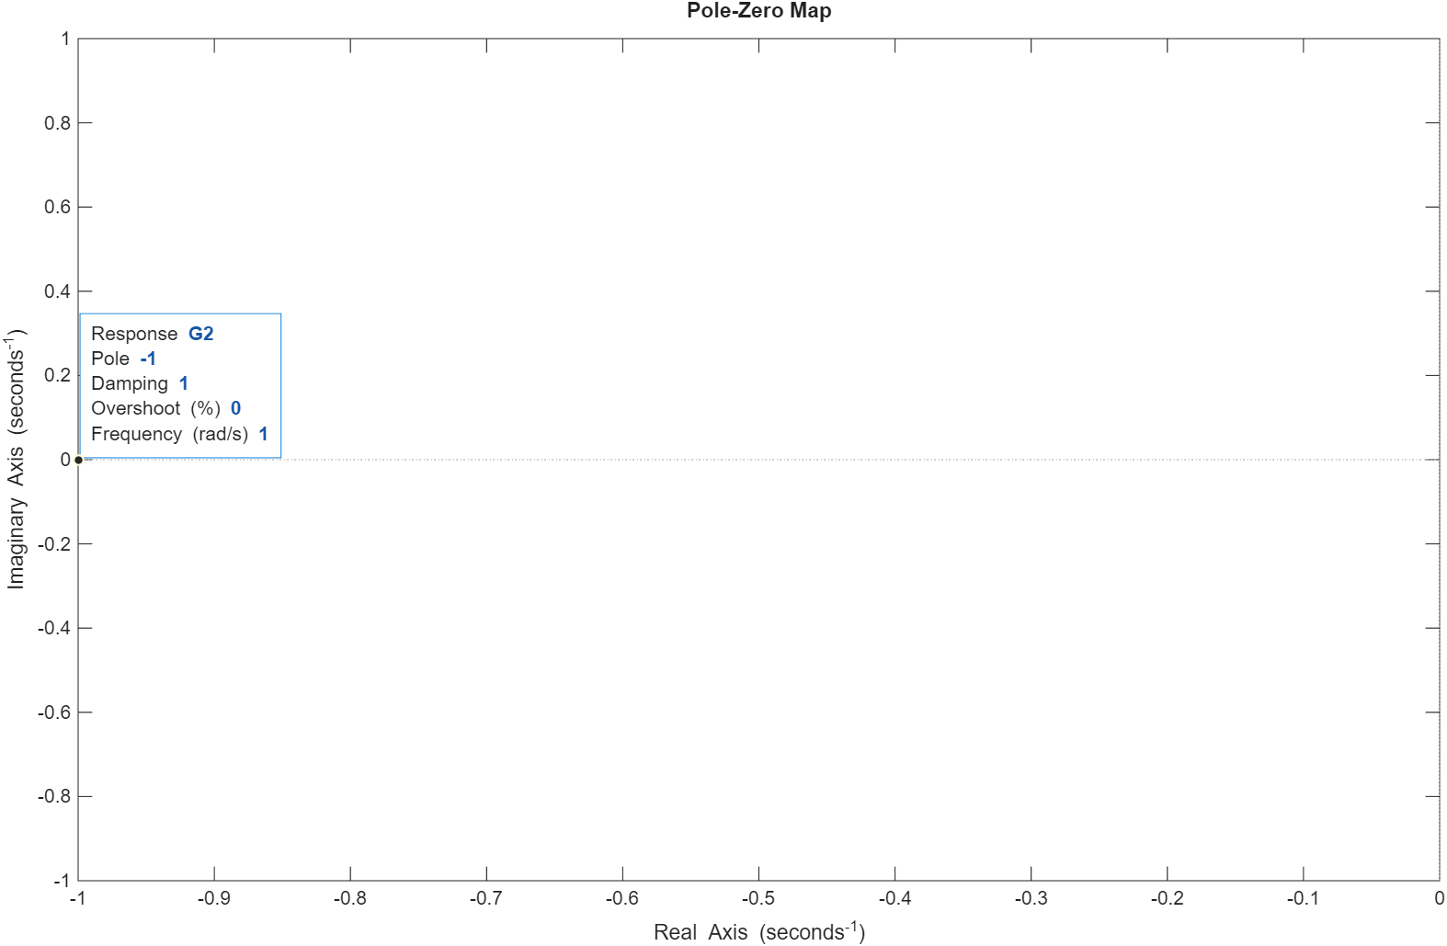

$$\begin{aligned}w_{n}\text{=}\sqrt{1}\text{=}1 \\ 2ξw_{n}→2 \\ ξ\text{=}\frac{2}{2w_{n}}\text{=}\frac{2}{2∗1}\text{=}1\end{aligned}$$

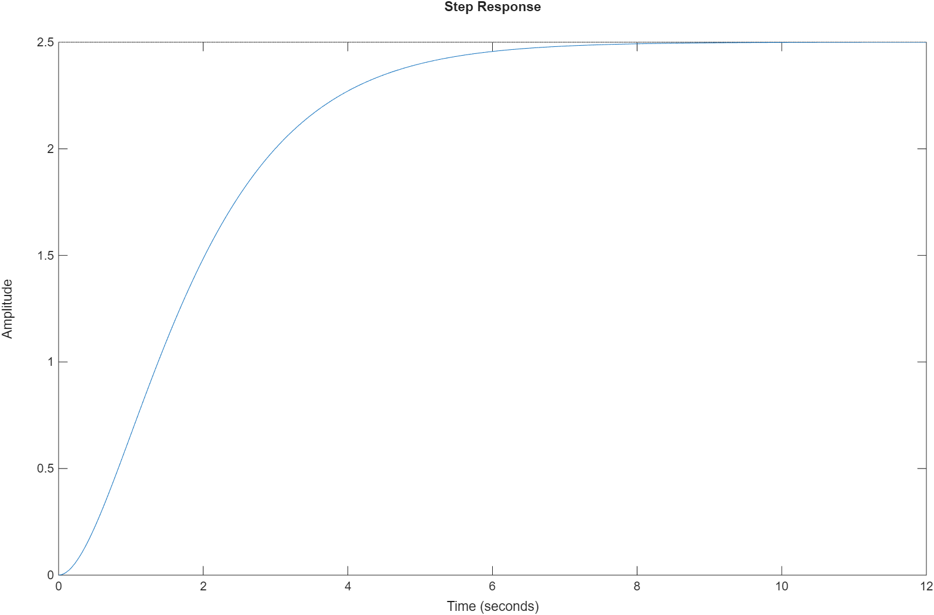
With a damping ratio of exactly 1, the system is critically damped. This is the boundary condition between oscillation and non_x005F_xfffe_oscillation, where the system returns to steady-state as quickly as possible without oscillating

1 -> Critically Damped

num3 = 5; % Numerator coefficients
den3 = [1 4 13]; % Denominator coefficients
G3 = tf(num3,den3) % Create transfer function

G3 =
5
--------------
s^2 + 4 s + 13
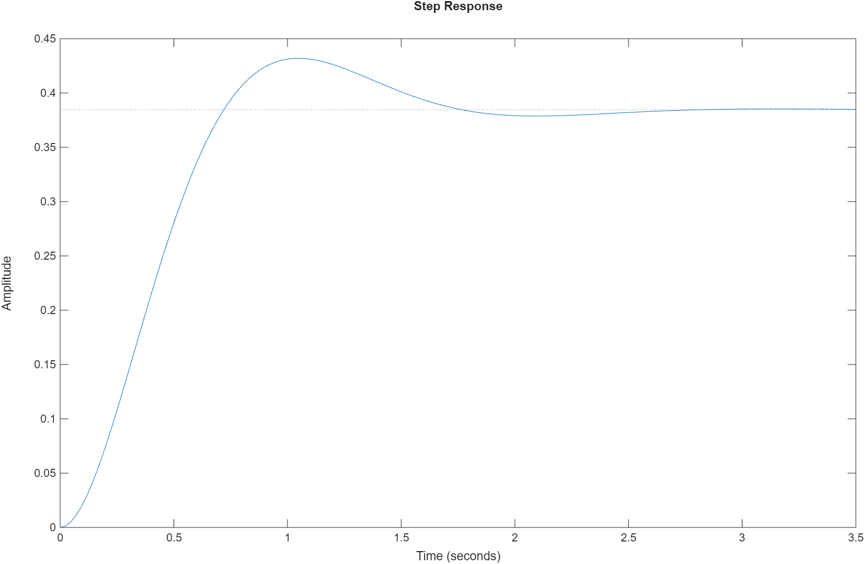

$$\begin{aligned}w_{n}\text{=}\sqrt{13}≈3.606 \\ 2ξw_{n}→4 \\ ξ\text{=}\frac{4}{2w_{n}}\text{=}\frac{4}{2∗3.606}≈0.554\end{aligned}$$

Since 0<ζ<1, the system is under-damped, meaning it will exhibit oscillations as it approaches steady-state

0.554 -> Underdamped

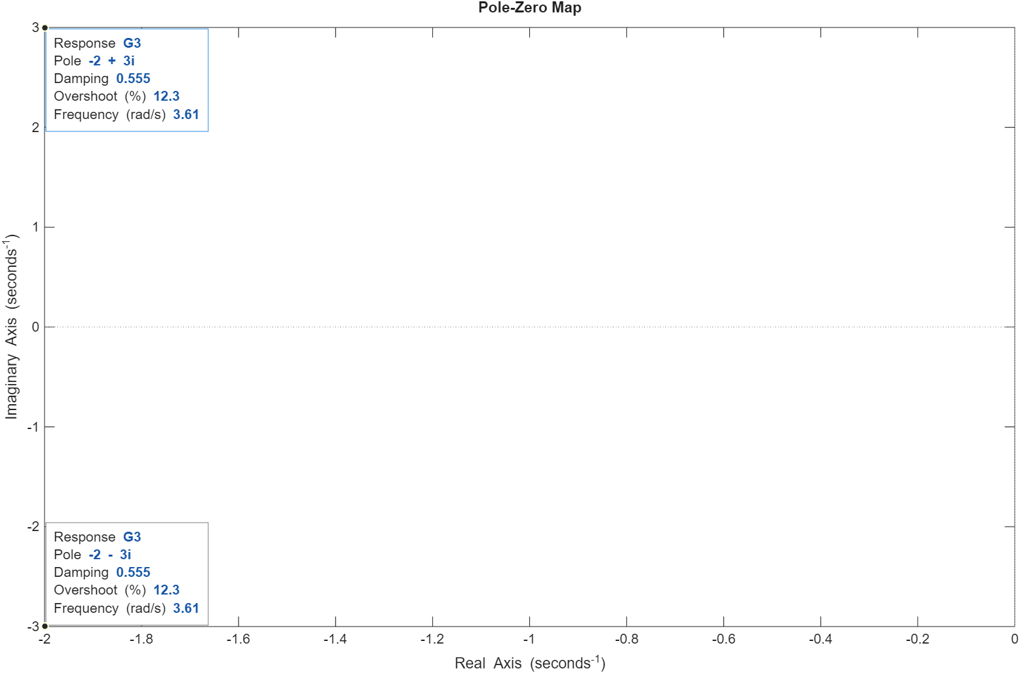

num4 = 10; % Numerator coefficients
den4 = [1 0 10]; % Denominator coefficients
G4 = tf(num4,den4) % Create transfer function

G4 =
10
--------
s^2 + 10
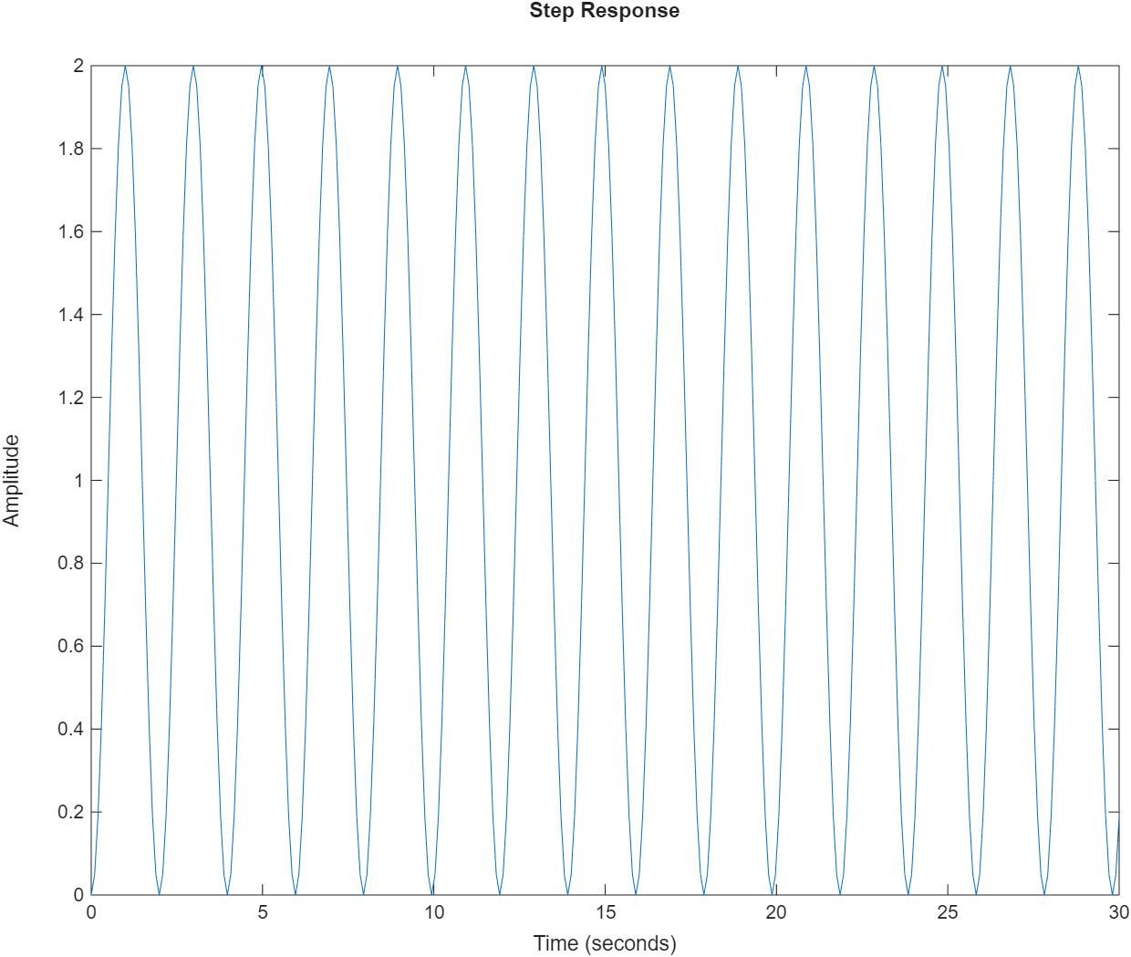

$$\begin{aligned}w_{n}\text{=}\sqrt{10}≈3.162 \\ ξ\text{=}0\end{aligned}$$

With a damping ratio of 0, there is no damping in the system, and it will oscillate indefinitely without settling to a steady-state value.

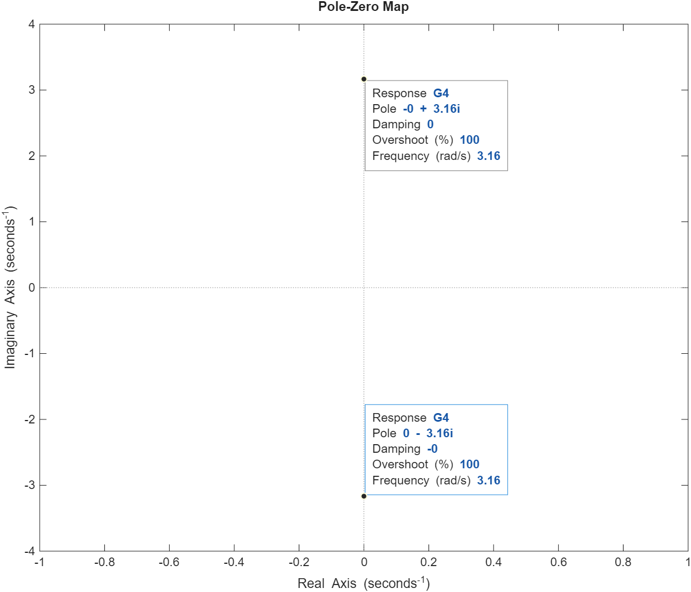
0 -> Undamped
Post Lab Assignment 2)
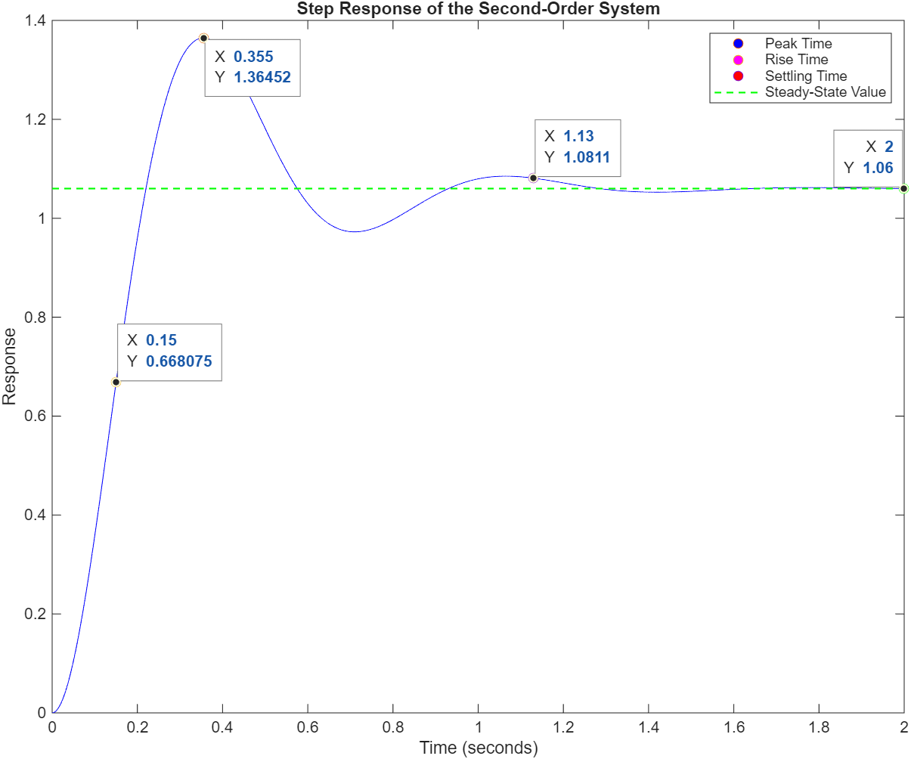
$$\begin{aligned}\text{\%}OS\text{=}100e^{−\frac{ξπ}{\sqrt{1−ξ^{2}}}} \\ ln\left(0.287\right)\text{=}−\frac{ξπ}{\sqrt{1−ξ^{2}}} \\ −1.251\text{=}−\frac{ξπ}{\sqrt{1−ξ^{2}}} \\ 1.251\text{=}\frac{ξπ}{\sqrt{1−ξ^{2}}} \\ \frac{1.251}{π}\text{=}\frac{ξ}{\sqrt{1−ξ^{2}}} \\ {0.398}^{2}\text{=}\frac{ξ^{2}}{1−ξ^{2}} \\ 0.1586\left(1−ξ^{2}\right)\text{=}ξ^{2} \\ 1.1586ξ^{2}\text{=}0.1586 \\ ξ^{2}\text{=}\frac{0.1586}{1.1586}\text{=}0.13689 \\ \sqrt{ξ^{2}}\text{=}\sqrt{0.13689} \\ ξ\text{=}0.369\end{aligned}$$

$$\begin{aligned}w_{n}\text{=}\frac{π}{T_{p}\sqrt{1−ξ^{2}}} \\ w_{n}\text{=}\frac{π}{0.355\sqrt{1−{\left(0.369\right)}^{2}}} \\ w_{n}\text{=}9.5215\end{aligned}$$

$\begin{aligned}G\left(s\right)\text{=}\frac{Kw_{n}^{2}}{s^{2}\text{+}2ξw_{n}s\text{+}w_{n}^{2}} \\ G\left(s\right)\text{=}\frac{1.06∗{\left(9.5215\right)}^{2}}{s^{2}\text{+}2\left(0.369\right)\left(9.5215\right)s\text{+}{\left(9.5215\right)}^{2}} \\ G\left(s\right)\text{=}\frac{96.0985}{s^{2}\text{+}7.027s\text{+}90.659}\end{aligned}$

% Question 2
% Define the transfer function
numerator = 96.0985;
denominator = [1, 7.027, 90.659];
system = tf(numerator, denominator);
% Mark steady-state value, peak time, rise time, and settling time
steady_state_value = 1.06;
peak_time = 0.355;
rise_time = 0.15;
settling_time = 1.13;
% Plot the step response
t = 0:0.001:2;
[y, t] = step(system, t);
figure;
plot(t, y, 'b-', 'MarkerSize', 1, 'DisplayName', 'Step Response');
hold on;
% Key point markers
h_peak = plot(t(find(t >= peak_time, 1)), y(find(t >= peak_time, 1)), 'o', 'MarkerFaceColor', 'blue', 'DisplayName', 'Peak Time');
h_rise = plot(t(find(t >= rise_time, 1)), y(find(t >= rise_time, 1)), 'o', 'MarkerFaceColor', 'magenta', 'DisplayName', 'Rise Time');
h_settle = plot(t(find(t >= settling_time, 1)), y(find(t >= settling_time, 1)), 'o','MarkerFaceColor', 'red', 'DisplayName', 'Settling Time');
% Green dashed line at steady-state value
h1 = plot([0 max(t)], [steady_state_value steady_state_value], 'g--', 'LineWidth', 1);
% Green steady-state marker
h2 = plot(t(end), steady_state_value, 'go', 'MarkerFaceColor', 'green');
% --- Combine steady-state line + marker into ONE legend entry ---
h_ss = [h1 h2];
% Labels
title('Step Response of the Second-Order System'); xlabel('Time (seconds)'); ylabel('Response');
% Final legend call (clean)
legend([h_peak h_rise h_settle h_ss], {'Peak Time', 'Rise Time', 'Settling Time', 'Steady-State Value'});

